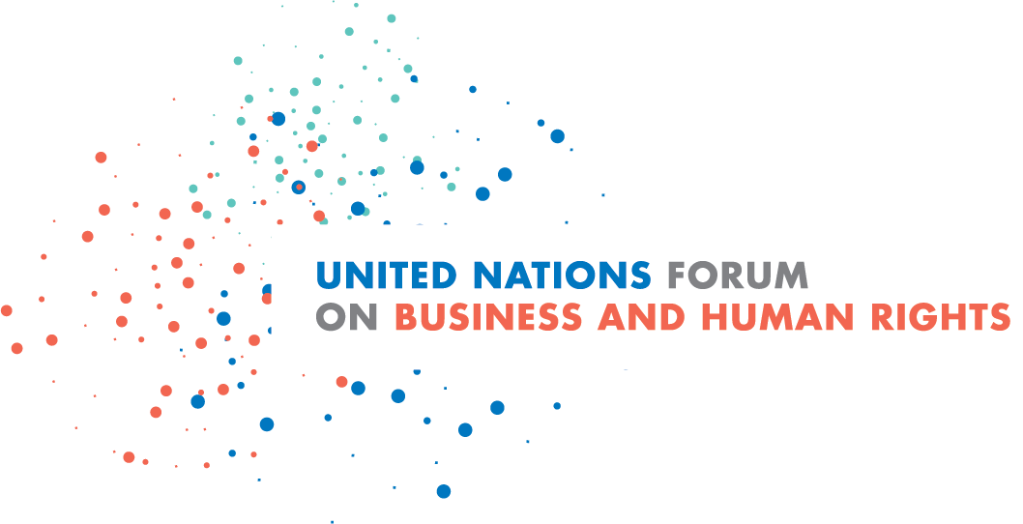
Concept Note
10th United Nations Forum on Business and Human Rights
29 November –1 December 2021

The next decade of business and human rights: increasing the pace and scale of action to implement the Guiding Principles on Business and Human Rights

Overview
Since its creation in 2011, the annual UN Forum on Business and Human Rights has brought together thousands of participants from governments, international organizations, business, trade unions, civil society, communities, lawyers and academia from around the world. Centred on the UN Guiding Principles on Business and Human Rights (UNGPs) – the global framework for States and businesses to prevent and address business-related impacts on human rights – the Forum has provided a unique multi-stakeholder platform for discussing trends and challenges in implementing the UNGPs and realizing a more sustainable global economy. As the UNGPs turned 10 in June 2021, the convergence of the COVID-19 and climate crises amid a number of other major global challenges underlined why the need to bridge the gaps between economic actors and respect for people and the planet is more pressing than ever. Set against this background, with the UNGPs as the central reference point for efforts toward bridging these gaps, the 10th annual Forum looks ahead to the next decade, engaging relevant actors in discussion on what it will take to increase the pace of UNGPs implementation toward 2030. Due to the ongoing worldwide challenges the COVID-19 pandemic continues to pose, the 10th Forum will take place virtually from 29 November to 1 December 2021.
The Forum was established by the UN Human Rights Council and is guided and chaired by the UN Working Group on Business and Human Rights. It is organized by the Office of the UN High Commissioner for Human Rights (OHCHR).

Focus of the 2021 Forum: a roadmap for action and key issues for the next decade of business and human rights
June 2021 marked the tenth anniversary of the unanimous endorsement by the Human Rights Council of the UNGPs. A major step forward in efforts to prevent and address business-related human rights abuse, they provide a common platform for action as the global authoritative framework for State duties and business responsibilities to achieve the UNGPs' vision of "tangible results for affected individuals and communities, and thereby also contributing to a socially sustainable globalization."
The 10th Forum provides a timely opportunity to look ahead and inspire a renewed push for scaled-up global implementation of the UNGPs by States and businesses in the decade toward 2030. Two outputs by the Working Group developed at the occasion of the UNGPs 10th anniversary provide a key reference for discussions at the 2021 Forum:
- The Working Group’s evaluation of the first decade of UNGPs implementation, presented in its “UNGPs 10+ stocktaking” report to the Human Rights Council in June 2021 and accompanied by a stocktaking on implementation by institutional investors.

- The Working Group’s “roadmap for the next decade”, setting out benchmarks and action areas for States, businesses and other stakeholders to address existing gaps and seize current opportunities identified by the UNGPs 10+ stocktaking. The “roadmap” is forthcoming in October/November 2021.
Together with other work done by the Working Group and OHCHR, these two outputs will help inform discussions between the different actors, including governments, businesses, civil society, trade unions, indigenous peoples, human rights defenders, national human rights institutions, academics, international organizations and others. Discussions in the Forum will allow all participants to share their perspectives on what’s next and what is needed to overcome the coherence and implementation gaps identified by the UNGPs 10+ assessment and realize the pathways for faster and wider UNGPs’ implementation and lasting impact toward 2030 that the UNGPs 10+ roadmap will set out.
In addition to plenary sessions and regional dialogues revolving around trends, challenges and opportunities for the UNGPs’ implementation, a number of thematic sessions will examine both long-standing and emerging issues such as the following:
- Connecting the UNGPs and climate change agendas
- Realizing an optimum “smart mix” of legal and policy measures, including effective mandatory human rights due diligence
- Addressing coherence gaps in State policy and practice to protect human rights, including in responses to the socio-economic crisis due to the pandemic
- The need to integrate human rights considerations in the key policy areas that shape economic activity such as the international investment agreements (building on the Working Group’s 2021 report to the General Assembly, A/76/238)
- Tackling the persisting and growing threats to human rights defenders speaking up against business-related harm to people and the planet
- Evaluating different efforts to improving access to remedy for rights-holders affected by business-related harm
- Implications of mandatory human rights due diligence for small and medium-size enterprises
- Developing better and more systematic tracking of State and business performance
- Ensuring that most at-risk rights-holders are at the centre of the next decade’s State and business efforts to prevent and address human rights harm

The full agenda will be posted on the Forum web page by end of September 2021.
Participating in the 2021 Forum
Due to the online format of the 2021 Forum, this year’s agenda will be lighter and leaner compared to previous editions of the Forum, while the event continues to cover a broad range of issues and will hear from a diverse group of relevant actors from all regions, thus serving as the leading UN platform for multi-stakeholder dialogue on business and human rights. Subject to public health regulations relating to the pandemic, in-person or hybrid elements of the Forum will be considered closer to the dates of the Forum as appropriate and as the situation allows. Information about the agenda, registration process and virtual participation will be posted on the Forum dedicated webpage in due course. In view of the above, no open call for session proposals and side events will be issued.

